# M01: Accuracy analysis

* When measuring, always report the digits you know for sure, plus one additional digit.
  + In this example, that is 3.14 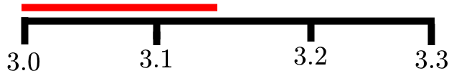
* Using this, report the **reading accuracy**.
  + 0.05 in this case
  + This is usually half the distance between two measures in the case of rulers and such.
  + It is also hals the difference between the two smallest digits on an electronic measurement device.
* With the reading accuracy, it becomes: d ± Δd = 3.14 ± 5 * 10-2 cm
  + In an answer, report accuracies in one significant digit
  + In an intermediate step, report accuracies in two significant digits
  + Least significant digit final result = digit of reported accuracy
* Important keywords
  + Measurement Error: The difference between the result of the experiment and the real value.
  + Measurement Uncertaintly: The maximum value the measurement error can be

# M02: Principles of experimental design

## Component analysis

Important factors are:

* Physical system: performance of the GX200, intrinsic fluctuations
* Measurement system: instrumentation accuracy, time effects, calibration
* Observer: training, reaction time, familiar with procedure
* Environment: temperature fluctuations, wind, vibrations
* Model and theory enough detail to explain everything

## Errors

* Systematic errors: consistent, repeatable errors
  + Usually have to do with poor equipment or bad design
  + In same direction/magnitude when repeated
  + Might be compensated for by calibration (rarely possible)
* Random errors
  + Completely unpredictable and unrepeatable
  + Can be compensated for using the average of multiple tests, possibly using more advanced statistics

## Accuracy and precision

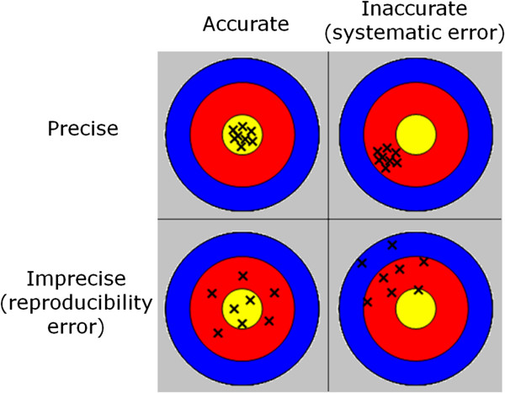

* Systematic errors 🡪 inaccuracies
* Random errors 🡪 imprecisions

## Repeatability and reproducibility

*Repeatable:* *concerns the measurement procedure*

The experiment is done multiple times at the same location, same conditions with the same observer. With all these constant factors, the real differences in a product can be measured.

*Reproducible:* *concerns the ability to replicate results by others*

The environment is constantly changing. Here the differences made by external factors can be measured. Think about the observer, location, other instruments.

## Accuracies

These are ways to formulate accuracy

If: 

|  |  |  |
| --- | --- | --- |
| Absolute accuracy |  | With dimension |
| Fractional accuracy (*precision*) |  | Dimensionless |
| Percentage accuracy |  | Dimensionless |

# M03 Propagation of accuracies

100% confidence interval

* Report the accuracy where you are 100% certain that is lays within the deviation you have set (the *maximum* deviation)
* Remember all the mathematical rules are abbreviations of the Taylor series

Mathematical rules:

* Sums: *Absolute accuracies*
  + 
* Differences: *Absolute accuracies*
  + 
* Linear combinations: *Absolute accuracies*
  + 
* Products: *Fractional accuracies*
  + 
* Quotients: *Fractional accuracies*
  + 
* Powers
  + 

Taylor’s approximations:

* One variable functions
  + 
  + 
* Multivariable
  +   
     
  +   
     

When you encounter a problem with fractions, consider analysing the inverse of everything under the denominator or use Taylor’s approach.

The abstract accuracies in table form:

|  |  |
| --- | --- |
| **Absolut Accuracies !** | **Fractional Accuracies !** |
| **General Rule: Taylor Approximation** | |